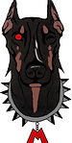
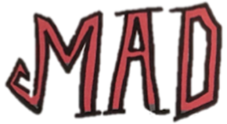

Credit/Debit Card Detail Form

- Submission Type –ALL CARDS SLABBED
Mark only one oval.
Grading is $15/card!! - Get your cards professionally Graded & Authenticated
Slabbing is $10/card!! - Card protection-includes NAME ONLY, no grading
Reholder is $10/card!! - Is your case scratched or scuffed? We can put your card in a new slab.
EXPRESS is $30/card!! - Authenticated & Graded. 5-7 day turnaround time
BULK GRADING Level A is $12/card!! - 100-499 cards submitted
BULK GRADING Level B is $9/card!! - submissions over 500+ cards
- Add Cards - Enter Player's Name, year, and manufacturer. Separate each item by numbering (e.g. 1. Fernando Tatis Jr., 2020, Topps 2. Roberto Alomar, 1988, Donruss etc.)

If you need more space, create a second document and attach it to this one.

- Comments / Requests

- Full Name *

- Email *

- Address *

- Phone Number *

- Total Number of Cards Submitted

Enclose with package and send cards to:
Mad Dog Grading at: 1869 E Seltice Way #566, Post Falls, ID, 83854

